**Scope Management Plan**

Madonna’s Web

**Madonna’s Garden Resort and Event’s Place**

**Gutierez Street**

**Malvar City, Batangas 4233**

**May 3, 2023**

**Table of Contents**

Introduction 4

Scope Management Approach 5

Roles and Responsibilities 5

Scope Definition 7

Project Scope Statement 7

Work Breakdown Structure 8

Scope Verification 9

Scope Control 10

Sponsor Acceptance 11

# Introduction

The goal of the project is to make Madonna's Resort's online interactions better by developing a website that will assist in solving their issues. The reservation system and other website elements that will be promoted online will be covered by the study. The customer can easily reserve a cottage and other amenities for the day of their reservation with the aid of the online booking system. By including a monthly sales report for the resort and digitizing it so that management can quickly examine their profit and track the days and weekly sales of Madonna's Resort, the developers will also add analytics to the project. Interviews with the client and their comments will help used by the developers to create an interactive and user-friendly website that can be beneficial to the customer and the business.

**Collect Requirements-** The researcher’s plan is to make a code that will make a website that consists of Madonna’s Web, where reservation system is the focus of the development of the system.

**Define Scope-** The business will be able to optimize the value of the project and ensure that it is contributing to the success of the business by coordinating the Madonna's Web project with the overall strategic aims and objectives of Madonna's Resort and Events Center.

**Create WBS-** The team, in coordination with the business, will identify and create the Work needed for the project and break it down as needed.

**Verify Scope-** The business will be able to maximize the value of the project and ensure that it is contributing to the success of the business by coordinating the Madonna's Web project with the overall strategic goals and objectives of Madonna's Resort and Events Center. The project aligns with this goal by enhancing through resolving the limitations they had when using their existing multiple websites.

**Control Scope-** Better admin and staff online engagement because the system has supplied and addressed the need and missing capabilities compared to the many platforms they utilized, giving them control and removing restrictions on what they can do. better reservations and bookings for customers, as the system contains a function that has been improved specifically for the company. Better productivity and fewer human errors are the results of Madonna's resort's increased efficiency and effectiveness. Enhanced insight into resort employees' work allows managers and owners to keep track of system progress and spot potential problems like human errors.

# Scope Management Approach

The person in charge of the scope management is Dennyson Castillo, and responsible for accepting and approving the project scope. Neil Lavarias is also responsible for the documentation of scope management in aiding the person in charge to ensure that every content that is added is authorized and accepted within the project scope. The scope management is being by the work performance measurements and quality checklists. For the process of changing the scope, the person in charge is the one who initiates and authorizes if the added content is align within the project.

# Roles and Responsibilities

Table 1 shows the team of professionals who will work on creating the scope and their respective roles on the project:

|  |  |  |
| --- | --- | --- |
| Role | Description | Name |
| Project Manager | Person in charge of Project Scope Management. | Dennyson Castillo II |
| Project Team Member | Another responsible person aiding the person in charge on working the scope management. | Neil Gareth Lavarias |
| Executive Sponsor | Provides executive support for the project. | Micheal James Gnilo |

## Table 1: The Scope Management Team

# Scope Definition

# Project Scope Statement

**Product Scope Description** – Madonna's Web will accomplish developing a website that integrates reservation system and other website elements that will be promoted online. Where the customer can easily reserve a cottage and other amenities for the day of their reservation with the aid of the online booking system. By including a monthly sales report for the resort and digitizing it so that management can quickly examine their profit and track the days and weekly sales of Madonna's Resort, the developers will also add analytics to the project to sort documents.

**Product Acceptance Criteria** - The researchers created a functioning system that incorporates a reservation system and enables customers to quickly book a cottage or other amenities online. will be used by the programmers to build an interactive and user-friendly website that will be advantageous to both the client and the company.

**Project Deliverables-** The integrated website that will help the Madonna’s reservation which will make it easier to record and make a statement of schedule of the user. Then it will record the customer information to make an appointment. So, after Madonna’s Website is done the code will be processed which helps define the system and understand how it works and the researchers will pass it to the client once it is done.

**Project Exclusions**

* Interactive Map – Similar to google maps but focuses on interacting only in the vicinity of Madonna’s Resort. It works by going through the interactive map page on the website and from there users can click the buildings which display the information or with the prices if they click the cottages. Due to time constraints, it has not been included in the project and it is outside of scope as the main objective is to have an online reservation system for the Madonna’ Resort.

**Project Constraints-** The Madonna Web system's possible benefits in relation to costs will be determined with the aid of the cost-benefit analysis. This project's main advantage is the increase in efficiency and precision in reservations, sales calculations, and advertising. The system's quicker reaction times will increase customer satisfaction and lower operating expenses. Because it is project-based learning and the framework used to develop the system is free, development and implementation have not cost. Because the client only had to pay a subscription fee to the system's preferred online cloud hosting provider in order for the project to go live online, maintenance costs were lower.

**Project Assumptions-** The project's goal is to create a system, which includes a website with a blog and a photo gallery, to assist Madonna's Resort with reservations. To give an overview of these tools, reservations are made by filling out a form on the website, which directs to a page that generates a receipt that the consumer may use to pay a deposit using Gcash because it is contained in the receipt. Then, depending on the situation, this will be transferred to the database where the resort's admin and staff who are logged in can check, confirm, edit, and remove the receipt.

# Work Breakdown Structure

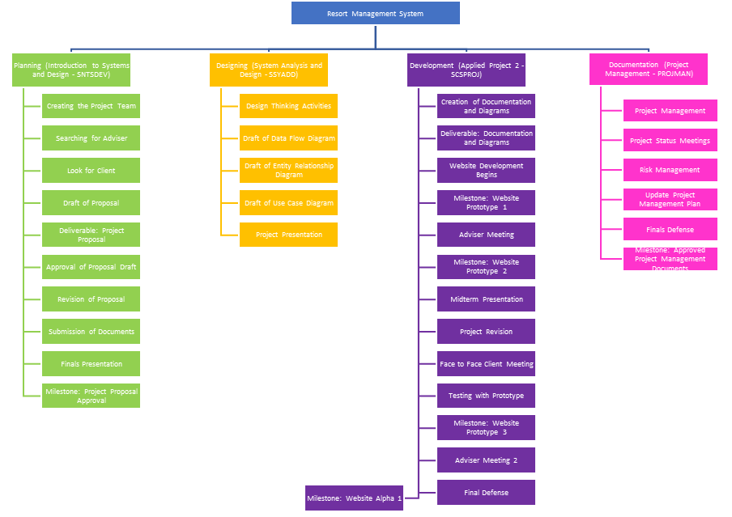

**Figure 1.1, *Work Breakdown Structure (WBS)***

|  |  |  |  |
| --- | --- | --- | --- |
| Level | WBS Code | Element Name | Definition |
| 1 | 1 | Resort Management System | All work to implement a new Reservation management system. |
| 2 | 1.1 | Planning (Introduction to Systems and Design - SNTSDEV) | The work to initiate the project. |
| 3 | 1.1.1 | Creating the Project Team | Creating the group of individuals who will work on the project |
| 3 | 1.1.2 | Searching for Adviser | Project Manager to find an adviser for the group |
| 3 | 1.1.3 | Look for Client | Project Team will find client to provide IT solution |
| 3 | 1.1.4 | Draft of Proposal | Project Team creates a draft of the Project Proposal which includes the plans for the project |
| 3 | 1.1.5 | Deliverable: Project Proposal | The Project Sponsor and the Adviser will read and give suggestion to the project proposal |
| 3 | 1.1.6 | Approval of Proposal Draft | The Project Sponsor and Adviser approves the Proposal Draft with comments to improve the system |
| 3 | 1.1.7 | Revision of Proposal | The Team revises the paper based on the feedback of the Project Sponsor, Adviser, and Panel |
| 3 | 1.1.8 | Submission of Documents | The Project Manager ensures that the documents needed is ready and has been submitted for grading |
| 3 | 1.1.9 | Finals Presentation | The Project Team Presents their proposal in front of panelist and their professors to ensure that all the criteria have been met |
| 3 | 1.1.10 | Milestone: Project Proposal Approval | After the Presentation, the team will have to revise and submit the paper which will be needed to be approved by the professors and the panelist |
| 2 | 1.2 | Designing (System Analysis and Design - SSYADD) | The work needed to design the System |
| 3 | 1.2.1 | Design Thinking Activities | The team under go Design Thinking Training to help understand the user |
| 3 | 1.2.2 | Draft of Data Flow Diagram | The Team works on the Data Flow Diagram |
| 3 | 1.2.3 | Draft of Entity Relationship Diagram | The Team works on the Entity Relationship Diagram |
| 3 | 1.2.4 | Draft of Use Case Diagram | The Team works on Use Case Diagram |
| 3 | 1.2.5 | Project Presentation | The Team presents their work to their professor their work |
| 2 | 1.3 | Development (Applied Project 2 - SCSPROJ) | The Team performs work to build and document the system design. |
| 3 | 1.3.1 | Creation of Documentation and Diagrams | The Team starts the creation of the needed documentation and diagrams for the system |
| 3 | 1.3.2 | Deliverable: Documentation and Diagrams | The team produces the necessary Documentation and Diagrams for the Project |
| 3 | 1.3.3 | Website Development Begins | The Team starts the Development of the System based on the Project Proposal, and Documentation and Diagrams |
| 3 | 1.3.4 | Milestone: Website Prototype 1 | The Team creates the first Prototype of the project which includes basic functionalities. |
| 3 | 1.3.5 | Adviser Meeting | The Team meets with their Adviser to help develop the Project and give feedback |
| 3 | 1.3.6 | Milestone: Website Prototype 2 | The Team Revises the prototype based on the feedback of the adviser and the Project Sponsor |
| 3 | 1.3.7 | Midterm Presentation | The Team Presents Their updates to their professor and to a board of panelist |
| 3 | 1.3.8 | Project Revision | The Team Revises the Diagram and Documentations, and the Prototype based on feedback |
| 3 | 1.3.9 | Face to Face Client Meeting | The Team meets with the Project Owner and the project sponsor to view the website |
| 3 | 1.3.10 | Testing with Prototype | Project Manager updates the Project Management Plan as the project progresses. |
| 3 | 1.3.11 | Milestone: Website Prototype 3 | The Team Produces the next version of the prototype based on the feedback of the professor and the panelist |
| 3 | 1.3.12 | Adviser Meeting 2 | The Team meets with their adviser to give feedback on their progress |
| 3 | 1.3.13 | Final Defense | The Team Defends their project Infront of a board of panelist to assure quality project is applied |
| 3 | 1.3.14 | Milestone: Website Alpha 1 | The team compiles all their work to produce a working Alpha project |
| 2 | 1.4 | Documentation (Project Management - PROJMAN) | All project related files and documents are formally archived. |
| 3 | 1.4.1 | Create draft of Project Management Documents | The Team works on the Project Management Documents |
| 3 | 1.4.2 | Deliverable: Project Management Documents | The Team Produces the Initial Project Management Documents |
| 3 | 1.4.3 | Milestone: Project Management Drafts | The Team releases the Draft of the Project Management Document |
| 3 | 1.4.4 | Revisions of Project Management Documents | The Team Revises the draft of the Project Management Documents based on feedback |
| 3 | 1.4.5 | Finals Defense | The Team Defends the Documentations |
| 3 | 1.4.6 | Milestone: Approved Project Management Documents | The team Produces an approved copy of the Project Management Documents |

# Scope Verification

The project team will use various techniques for scope verification to guarantee that the Dispatch Directory System project deliverables satisfy the original scope. These methods include:

* **Quality Checklists**
* These lists will outline the specific requirements that each deliverable is met to be accepted. The project team will use these checklists to verify that each deliverable meets all necessary criteria before moving forward.
* **Work Performance Measurements**
* The project team will track and measure the progress of each deliverable as it is being developed. This will allow the team to identify potential issues or deviations from the original scope and address them in a timely manner.
* **Scope Baseline**
* The project team will create and maintain a scope baseline, which is a snapshot of the original project scope. Any changes to the scope must be documented and approved before they are implemented. The scope baseline will be used to ensure that the final deliverables meet the original scope.
* **Formal Acceptance**
* The project sponsor, customer, and other stakeholders will formally accept each deliverable as it is completed. To ensure that the project team is meeting the expectations of all relevant parties – allowing any necessary feedback or changes to be made in a timely manner.

# Scope Control

The scope control process for the project will involve regular reviews of the project’s progress to ensure that they align with the original project scope as defined in the Project Scope statement. The Project Manager will be responsible for monitoring and controlling the project’s scope, with assistance from the project team and stakeholders. Periodic reviews of the project’s scope will be conducted to ensure that the project remains on track and within the defined boundaries.

The scope control process for the Madonna’s Web project will involve the following steps for making the changes to the scope baseline:

1. A scope change request will be initiated by the stakeholder or team member who identifies a need for change to the scope.
2. The scope change request will be reviewed by the Project Manager and Project Sponsor to assess the impact on the project schedule, budget, and resources.
3. If the change is deemed low impact, the Project Manager and Project Sponsor can approve or deny the request. If the change is deemed high impact, the Project Manager and Project Sponsor can approve or deny the request.
4. If the request is approved, the Project Manager will create an action plan to proceed with the change and update the scope baseline and notify all relevant stakeholders of the change.
5. If the request is rejected, the project team will continue with the project scope.

# Sponsor Acceptance

Approved by the Project Sponsor:

Date: 05/03/2023

Micheal James Gnilo

Owner, Madonna’s Resort